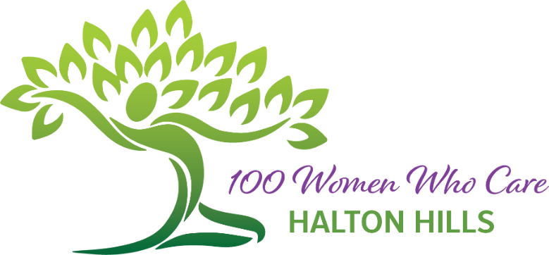 | Charity & Non-Profit Nomination Form

Member Information
First Name | Last Name

Email address | Phone Number

Nomination
Official Name of Charity or Non-Profit Organization

Address of Charity / Non-Profit Organization
Street Address | Unit/Apt #

Town | Province | Postal Code

Website Address | Phone Number

Is the charity registered on Canada Helps? Yes No
If No, the Charity must agree to issue manual tax receipts within one month of receipt of cheques from our members. Agreed
Charity Registration Number

Non-Profit: Does the organization have Letters Patent or Articles according to the Ontario Not-for-Profit Corporations Act? Yes No
If Yes, please attach a copy to this form.

Organization Contact Information
Contact Name | Position within Organization

Email address | Phone Number

Nomination Details
Organization’s Mission Statement

Current Sources of Funding

100WWCHH
Donations will be used for…

Geographical Area Served by the Organization

If the Charity / Non-Profit serves a larger area than Halton Hills, explain how the organization will ensure that the funds remain exclusively in Halton Hills. (This could mean a special project listing on Canada Helps.)

If this organization is selected by our members, will a member of this organization be available to speak at our next meeting to describe the impact of the donated funds?  Yes No | The organization agrees not to sell, give away, or use the 100 Women Who Care Halton Hills membership list and contact information for solicitation purposes.  Yes No

Please email your completed application,
including Letters Patent or Articles if required,
to:
info@100womenhaltonhills.com

Thank You for your Nomination

We will contact you shortly.

